(A typical Specimen of Cover Page & Title Page)

<Font Style Times New Roman - Bold>

# PROJECT TITLE

<Font Size 18> <1.5 line spacing>

A PROJECT REPORT [INTERNSHIP REPORT]

<Font Size 14>

#### Submitted by

<Font Size 14> <Italic>

STUDENT1 NAME [REG NUM]

STUDENT2 NAME [REG NUM]

<Font Size 16>

#### Under the Guidance of

<Font Size 14> <Italic>

## (GUIDE NAME )

<Font Size 16>

(Designation, Department)

<Font Size 12>

### *in partial fulfillment of the requirements* *for the degree of*

<Font Size 14> <1.5 line spacing>

## BACHELOR OF TECHNOLOGY

## in

## COMPUTER SCIENCE ENGINEERING

## with specialization in (SPECIALIZATION NAME)

<Font Size 16>

## DEPARTMENT OF COMPUTATIONAL INTELLIGENCE COLLEGE OF ENGINEERING AND TECHNOLOGY

SRM INSTITUTE OF SCIENCE AND TECHNOLOGY

## KATTANKULATHUR- 603 203

<Font Size 16><l.5 line spacing>

### MAY 2025<Font Size 14>

Department of Computational Intelligence

##### SRM Institute of Science & Technology

##### Own Work* Declaration Form

This sheet must be filled in (each box ticked to show that the condition has been met). It must be signed and dated along with your student registration number and included with all assignments you submit – work will not be marked unless this is done.

To be completed by the student for all assessments

##### Degree/ Course :

**Student Name :**

##### Registration Number :

**Title of Work :**

I / We hereby certify that this assessment compiles with the University’s Rules and Regulations relating to Academic misconduct and plagiarism**, as listed in the University Website, Regulations, and the Education Committee guidelines.

I / We confirm that all the work contained in this assessment is my / our own except where indicated, and that I / We have met the following conditions:

* Clearly referenced / listed all sources as appropriate
* Referenced and put in inverted commas all quoted text (from books, web, etc)
* Given the sources of all pictures, data etc. that are not my own
* Not made any use of the report(s) or essay(s) of any other student(s) either past or present
* Acknowledged in appropriate places any help that I have received from others (e.g. fellow students, technicians, statisticians, external sources)
* Compiled with any other plagiarism criteria specified in the Course handbook / University website

I understand that any false claim for this work will be penalized in accordance with the University policies and regulations.

|  |
| --- |
| **DECLARATION:** |
| I am aware of and understand the University’s policy on Academic misconduct and plagiarism and I certify that this assessment is my / our own work, except where indicated by referring, and that I have followed the good academic practices noted above. |
| If you are working in a group, please write your registration numbers and sign with the date for every student in your group. |

# Logo

# SRM INSTITUTE OF SCIENCE AND TECHNOLOGY KATTANKULATHUR – 603 203

<Font Style Times New Roman — Size - 18>

## BONAFIDE CERTIFICATE

<Font Style Times New Roman — Size - 16>

<Font Style Times New Roman — Size - 14>

Certified that 21CSP302L - Project report titled “**PROJECT TITLE** ” is the bonafide work of “**STUDENT1 NAME [REG NUM], STUDENT2 NAME [REG NUM]”** who carried out the project work under my supervision. Certified further, that to the best of my knowledge the work reported herein does not form any other project report or dissertation on the basis of which a degree or award was conferred on an earlier occasion on this or any other candidate.

<<Signature >> <<Signature >>

**SIGNATURE SIGNATURE**

##### <<Name >> DR. R. ANNIE UTHRA

|  |  |  |
| --- | --- | --- |
| **SUPERVISOR**  [Designation]  [Department] |  | **PROFESSOR &HEAD**  DEPARTMENT OF  COMPUTATIONAL INTELLIGENCE |

Examiner 1 Examiner 2

**ACKNOWLEDGEMENTS**

We express our humble gratitude to **Dr. C. Muthamizhchelvan**, Vice-Chancellor, SRM Institute of Science and Technology, for the facilities extended for the project work and his continued support.

We extend our sincere thanks to **Dr. Leenus Jesu Martin M,** Dean-CET, SRM Institute of Science and Technology, for his invaluable support.

We wish to thank **Dr. Revathi Venkataraman**, Professor and Chairperson, School of Computing, SRM Institute of Science and Technology, for her support throughout the project work.

We encompass our sincere thanks to, **Dr. M. Pushpalatha**, Professor and Associate Chairperson - CS, School of Computing and **Dr. Lakshmi,** Professor and Associate Chairperson -AI, School of Computing, SRM Institute of Science and Technology, for their invaluable support.

We are incredibly grateful to our Head of the Department, <<Name , Designation & Department>>, SRM Institute of Science and Technology, for her suggestions and encouragement at all the stages of the project work.

We want to convey our thanks to our Project Coordinators, Panel Head, and Panel Members Department of Computational Intelligence, SRM Institute of Science and Technology, for their inputs during the project reviews and support.

We register our immeasurable thanks to our Faculty Advisor, ..................., Department of <<Dept. Name>>, SRM Institute of Science and Technology, for leading and helping us to complete our course.

Our inexpressible respect and thanks to our guide, ....................., Department of <<Dept. Name>>, SRM Institute of Science and Technology, for providing us with an opportunity to pursue our project under his / her mentorship. He / She provided us with the freedom and support to explore the research topics of our interest. His / Her passion for solving problems and making a difference in the world has always been inspiring.

We sincerely thank all the staff members of <<Dept. Name>>, School of Computing, S.R.M Institute of Science and Technology, for their help during our project. Finally, we would like to thank our parents, family members, and friends for their unconditional love, constant support and encouragement

Authors

### **ABSTRACT**

**TABLE OF CONTENTS**

**ABSTRACT iv**

**TABLE OF CONTENTS v**

**LIST OF FIGURES vi**

**LIST OF TABLES vii**

**ABBREVIATIONS viii**

**CHAPTER NO.**  **TITLE**  **PAGE NO.**

**1 INTRODUCTION 1**

1.1 Introduction to Project 2

1.2 Motivation 3

1.3 Sustainable Development Goal of the Project 4 1.4 Product Vision Statement 5

1.5 Product Goal 6

1.6 Product Backlog (Key User Stories with Desired Outcomes) 7

1.7 Product Release Plan 8

**2** **SPRINT PLANNING AND EXECUTION 9**

**2.1** **Sprint 1 10** 2.1.1 Sprint Goal with User Stories of Sprint 1 11

2.1.2 Functional Document 12

2.1.3 Architecture Document 13

2.1.4 UI Design 14

2.1.5 Functional Test Cases 15

2.1.6 Daily Call Progress 16

2.1.7 Committed vs Completed User Stories 17

2.1.8 Sprint Retrospective 18

**2.2 Sprint 2 19**

2.2.1 Sprint Goal with User Stories of Sprint 2 20

2.2.2 Functional Document 21

2.2.3 Architecture Document 22

2.2.4 UI Design 23

2.2.5 Functional Test Cases 24

2.2.6 Daily Call Progress 25

2.2.7 Committed vs Completed User Stories 26

2.2.8 Sprint Retrospective 27

**3.** **RESULTS AND DISCUSSIONS 28**

3.1 Project Outcomes (Justification of outcomes and how they align 29

with the goals)

3.2 Committed vs Completed User Stories 30

**4 CONCLUSIONS & FUTURE ENHANCEMENT 31**

**APPENDIX 32**

**A. PATENT DISCLOSURE FORM 33**

**B. SAMPLE CODING 34**

**C. PLAGIARISM REPORT 35**

**LIST OF FIGURES**

**CHAPTER NO TITLE PAGE NO.**

**LIST OF TABLES**

**CHAPTER NO TITLE PAGE NO.**

**ABBREVIATIONS**

**CHAPTER 1**

**INTRODUCTION**

**1.1 Introduction to Ai E-learning Application:**

The envisioned platform seamlessly integrates AI-powered personalized learning with a dynamic, local community-based skill-sharing ecosystem. It offers tailored learning experiences by leveraging advanced AI algorithms to assess users' preferences, abilities, and learning goals, creating customized learning paths that adapt over time. This personalized approach ensures each user progresses at their own pace, focusing on relevant content that maximizes engagement and learning outcomes. The AI curates educational content and provides intelligent feedback and suggestions for improvement, fostering continuous growth.

In addition to the AI-driven learning, the platform features a unique skill-sharing community where users can connect with others to teach and learn in live peer-to-peer sessions. This community-driven approach encourages skill-sharing through interactive video lessons, allowing participants to gain hands-on experience and insights from real people in their local area. Users can share their expertise on various topics, learn new skills from others, and even collaborate on projects, making the learning experience highly interactive and socially enriched. This blend of personalized AI guidance and local community collaboration creates a vibrant learning environment that empowers individuals to learn, grow, and share their knowledge with others.

**1.2 Motivation**

The motivation behind this platform stems from the need to make learning more accessible, personalized, and socially engaging. Traditional education systems often adopt a one-size-fits-all approach, which can leave individuals feeling disconnected or underserved. Many learners struggle to find relevant resources that match their unique abilities or interests, while others seek more interactive and practical learning opportunities that go beyond passive content consumption. The platform addresses these challenges by harnessing AI to deliver customized learning paths that adapt to each user’s needs, ensuring a more effective and engaging educational experience.

Moreover, communities are filled with untapped potential and knowledge, yet there is often no structured way to share and learn skills within a local context. This platform seeks to bridge that gap by integrating a skill-sharing community where users can connect, teach, and learn from one another through live, interactive sessions. By fostering a culture of peer-to-peer learning, it not only enhances knowledge transfer but also builds a sense of belonging and mutual support. The platform aims to transform learning from an isolated task into a collaborative journey, empowering people to grow together and leverage local expertise to achieve their personal and professional goals.

**1.3 Sustainable Development Goal of the Project**

The platform's focus on **Quality Education** aligns directly with the United Nations' Sustainable Development Goal 4 (SDG 4), which aims to ensure inclusive and equitable quality education and promote lifelong learning opportunities for all. By integrating AI-powered personalized learning with a community-based skill-sharing approach, the platform addresses several key aspects of SDG 4, such as accessibility, inclusivity, and lifelong learning. It breaks down traditional barriers to education by providing tailored learning experiences that cater to individual needs, ensuring that everyone, regardless of background or ability, has the opportunity to learn at their own pace and level.

Furthermore, the platform's emphasis on local community engagement enriches the educational experience by facilitating peer-to-peer learning and skill-sharing. This not only empowers individuals to learn new skills but also encourages community members to contribute to the education of others, fostering a culture of shared knowledge and support. Through interactive video sessions and live collaborations, the platform helps learners gain practical experience and social connections, which are essential for sustainable personal and community development.

By promoting quality education through innovative technology and local collaboration, the platform contributes to a sustainable educational ecosystem where learning is continuous, inclusive, and adaptive to the evolving needs of society. It helps to close educational gaps, supports diverse learning needs, and cultivates a global community of lifelong learners committed to personal growth and the sustainable development of their communities.

**1.4 Product Vision Statement**

1.4.1. Audience:

- Primary Audience: Learners seeking personalized education and community-based skill sharing.

- Secondary Audience: Educators and community experts looking to share their knowledge and interact with learners.

1.4.2. Needs:

- Primary Needs:

- Personalized learning paths tailored to individual preferences and progress.

- Real-time peer-to-peer learning sessions and feedback.

- Gamified elements to enhance engagement and motivation.

- Secondary Needs:

- Tools for tracking learning progress and skills improvement.

- Community features for collaborative learning and skill-sharing.

- Sentiment analysis to adapt learning experiences based on user feedback and engagement.

1.4.3. Products:

- Core Product: An AI-powered learning platform integrating personalized learning paths, live peer-to-peer sessions, and community

- Additional Features:

- Sentiment analysis for real-time feedback during sessions.

- Enhanced search functionality for easy access to relevant content.

- Gamification elements, including points, badges, and leaderboards.

- Feedback mechanisms and bug tracking for continuous improvement.

1.4.4. Values:

- Core Values:

- Personalization: Tailoring learning experiences to individual needs and preferences.

- Community: Fostering a collaborative environment for skill-sharing and mutual learning.

- Engagement: Using gamification to make learning interactive and fun.

- Differentiators:

- AI Personalization: Leveraging AI to create adaptive learning paths and provide real-time feedback.

- Live Peer Engagement: Facilitating real-time interactions and learning sessions.

- Gamified Learning: Incorporating points, badges, and leaderboards to motivate learners.

* 1. **Product Goal**

The primary goal of the platform is to revolutionize the learning experience by providing a personalized, community-driven approach to education. The platform aims to empower individuals by offering customized learning paths that adapt to their unique preferences, abilities, and goals, ensuring that every user can achieve their full potential. By leveraging AI technology, the platform continuously assesses and refines the learning journey, making it more engaging and effective over time. This goal is rooted in making quality education accessible to everyone, regardless of location or background, by breaking down barriers to entry and promoting lifelong learning.

In addition to personalized learning, the platform seeks to foster a vibrant skill-sharing community that encourages individuals to actively participate in teaching and learning. The goal is to create a sustainable educational environment where users not only gain knowledge but also contribute to the learning of others through live, peer-to-peer sessions. This approach ensures that learning extends beyond individual progress to community growth, enabling the transfer of valuable skills and experiences within local contexts.

Ultimately, the product goal is to create an educational ecosystem that is not just about acquiring information, but about building meaningful connections, promoting collaboration, and driving sustainable development in communities. Through this blend of AI-driven personalization and local skill-sharing, the platform aspires to make education a collaborative, enriching, and socially impactful experience.

**1.6 Product Backlog**

|  |  |
| --- | --- |
| **S.No** | **User Stories of AI E-Learning Application** |
| #US 1 | As a new user, I want to easily register for the platform so that I can gain access to its features like Profile creation and skill enhancement and resources for self-learning. |
| #US 2 | As a new user, I want to create a personal profile after registration so that I can showcase my skills, interests, and achievements to the community. |
| #US 3 | As a user, I want to search for skills, courses, and other users on the platform so that I can choose the relevant course according to my skill sets |
| #US 4 | As a user, I want to create and browse skill-sharing listings so that I can offer my skills to others and discover opportunities to learn new skills from others. |
| #US 5 | As a user, I want to participate in peer-to-peer learning sessions so that I can gain knowledge from others and share my expertise in a collaborative environment. |
| #US 6 | As a video provider, I want to post a quiz so that the learners can find the assessments and evaluate their understanding of the content. |
| #US 7 | As a user, I want real-time feedback during peer learning sessions so that I can immediately improve my skills and understanding based on the input from my peers. |
| #US 8 | As a user, I want the platform to analyze facial expressions so that it can provide sentiment analysis and help me better understand the emotional reactions during interactions. |
| #US 9 | As a user, I want to engage in forums and group activities so that I can collaborate with others, share ideas, and learn from the community |
| #US 10 | As a user, I want enhanced search functionality so that I can find relevant content quickly and efficiently without having to browse through unrelated information. |
| #US 11 | As a user, I want to provide feedback on the platform’s features and content so that I can help improve the user experience and ensure the content meets my needs. |

The product backlog of Ai E-learning Application was configured using the MS planner Agile Board which is represented in the following Figure 1.1. The Product Backlog consists of the complete user stories of Ai based E-learning Application

Each user story consist of necessary parameters like MoSCoW prioritization, Functional and non functional parameters, detailed acceptance criteria with linked tasks.

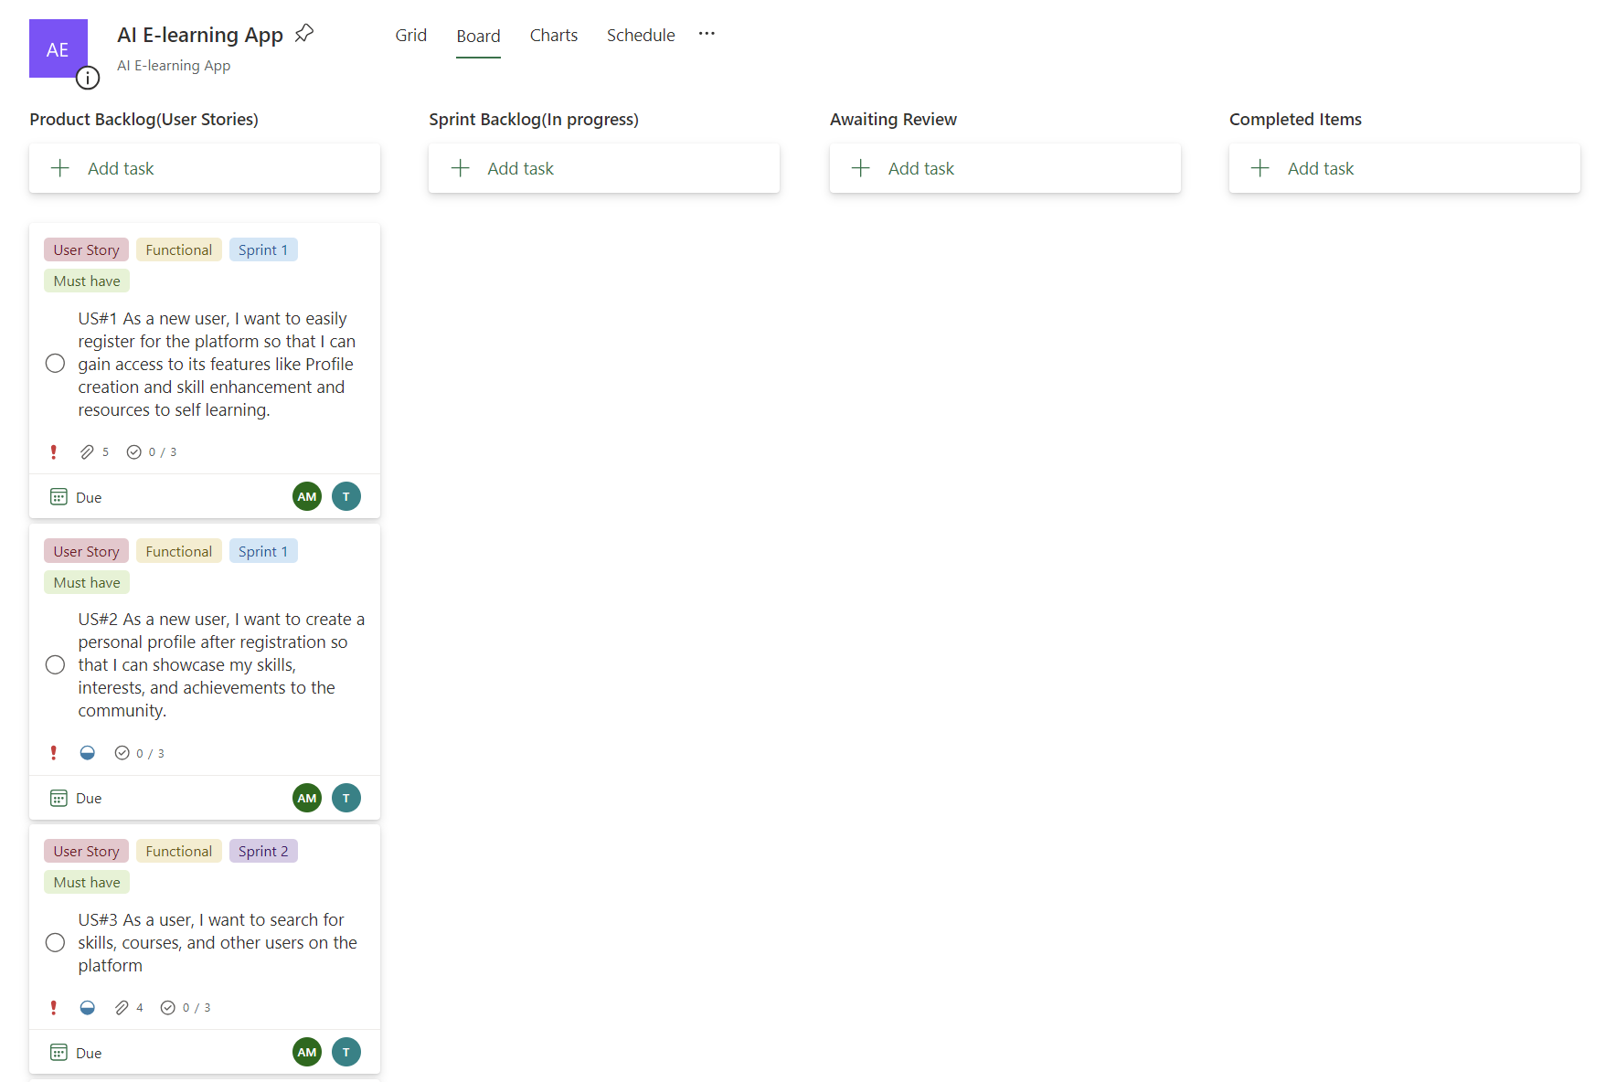Figure 1.1 MS Planner Board of Ai E-learning Application

**1.7 Product Release Plan**

The following Figure 1.2 depicts the release plan of the project

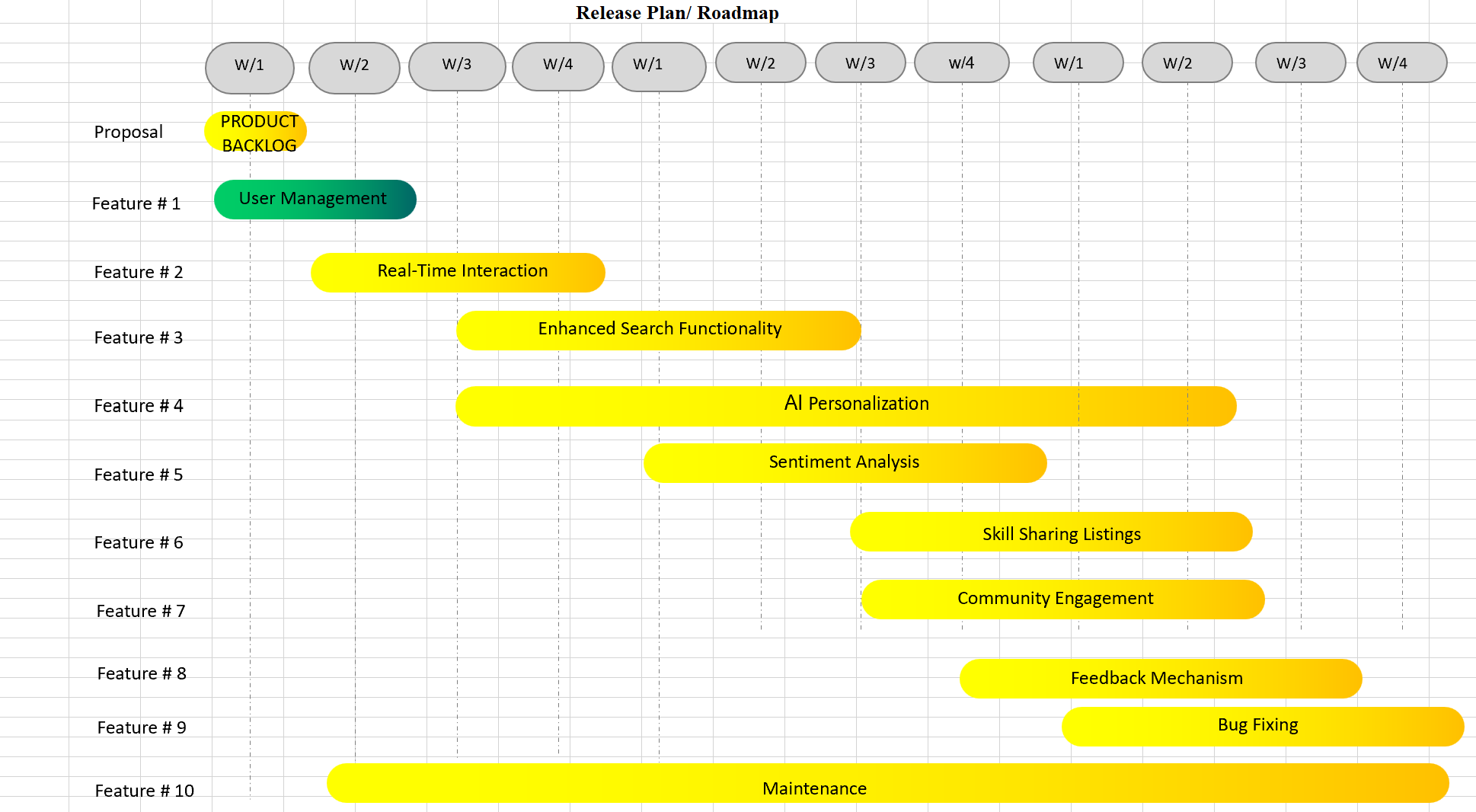

Figure 1.2 Release plan of AI E-learning Application

**CHAPTER 2**

**SPRINT PLANNING AND EXECUTION**

**2.1 Sprint 1**

**2.1.1 Sprint Goal with User Stories of Sprint 1**

The Goal of the first sprint is to construct the user landing page and to enable the search functionalities such as skills and courses.

The following table 2.1 represents the detailed user stories of the sprint 1

**Table 2.1 Detailed User Stories of sprint 1**

|  |  |
| --- | --- |
| **S.NO** | **Detailed User Stories** |
| US #1 | As a new user, I want to easily register for the platform so that I can gain access to its features like Profile creation and skill enhancement and resources to self learning. |
| US #2 | As a new user, I want to create a personal profile after registration so that I can showcase my skills, interests, and achievements to the community. |
| US #3 | As a user, I want to search for skills, courses, and other users on the platform |

Planner Board representation of user stories are mentioned below figures 2.1,2.2 and 2.3

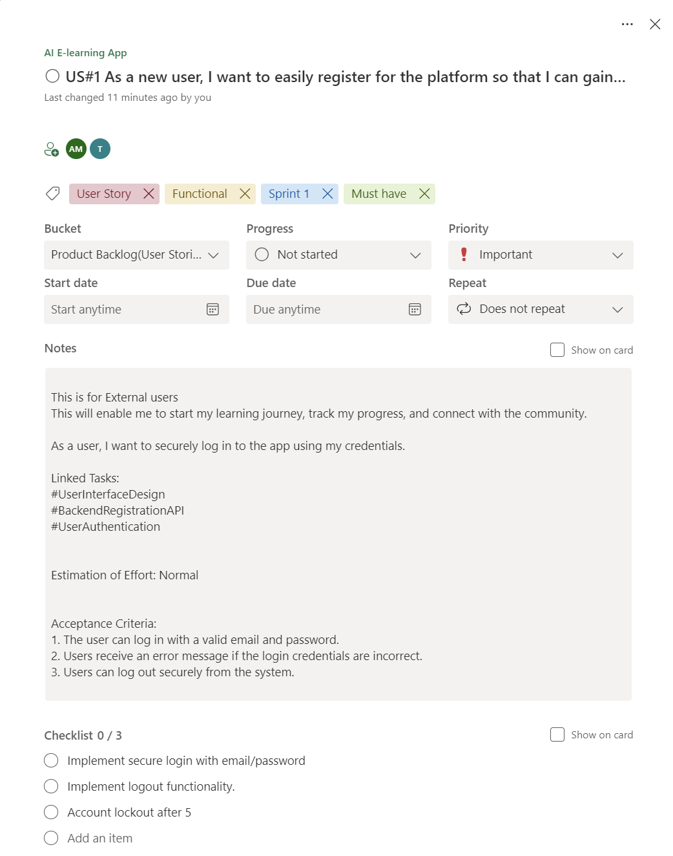

Figure 2.1 user story for user registration

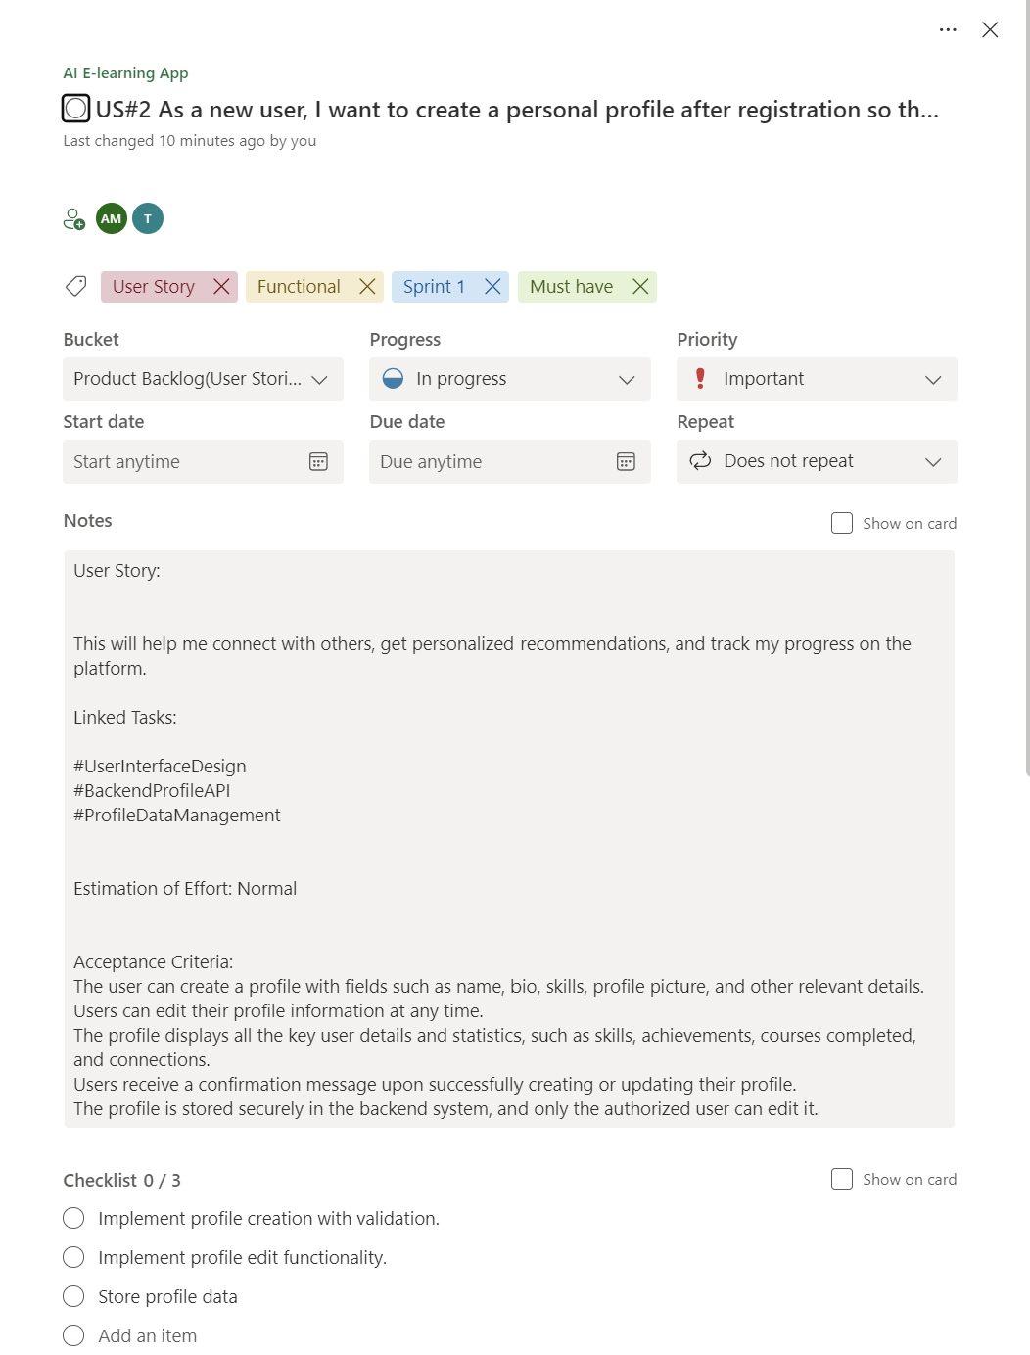

Figure 2.2 user story for profile creation

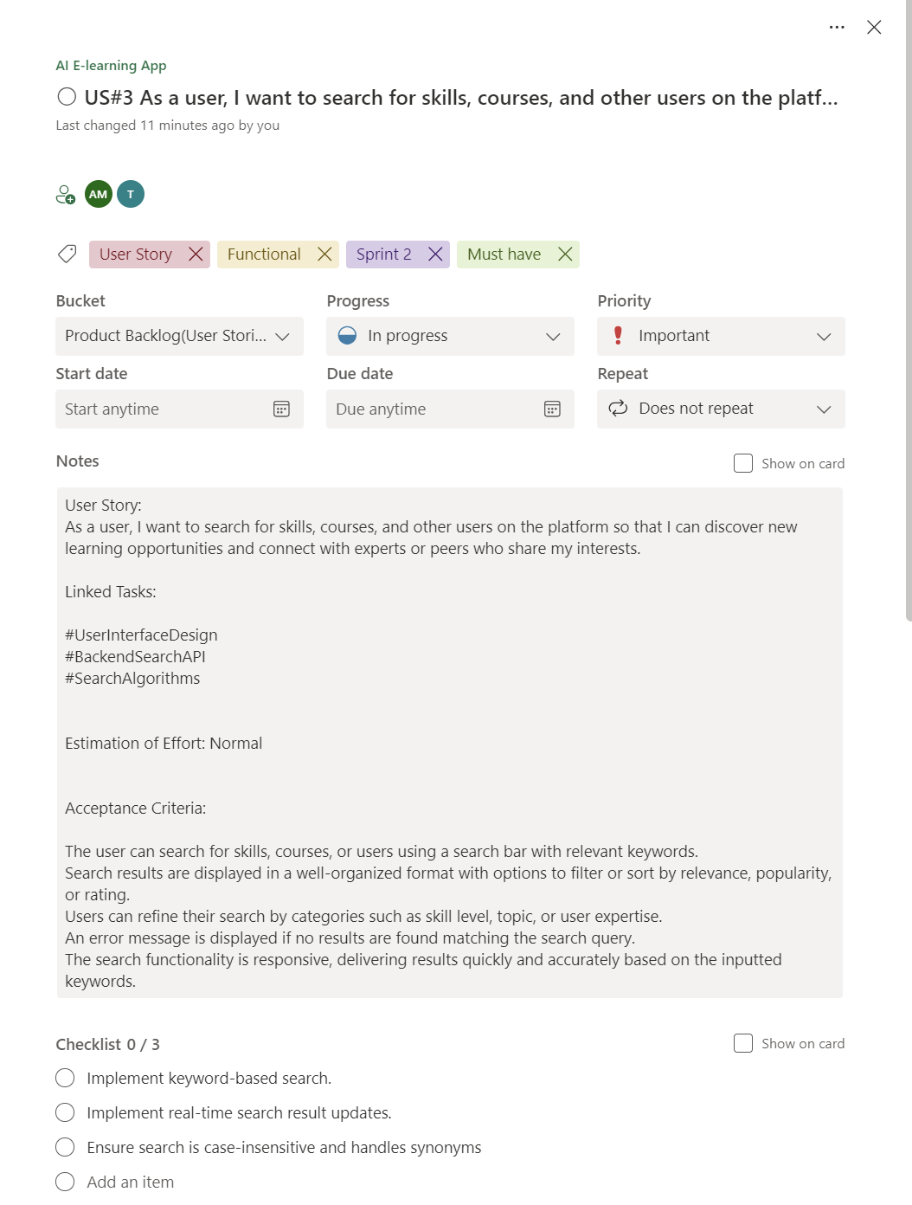

Figure 2.3 User story for search functionality

**2.1.2 Functional Document**

2.1.2.1. Introduction

The AI-Powered Skill-Sharing and Learning Platform project aims to create a dynamic, user-centric platform that combines artificial intelligence with community collaboration. This project focuses on delivering personalized learning experiences, facilitating real-time peer-to-peer engagement, and fostering a collaborative learning environment. The platform is designed to address the diverse needs of learners by providing tailored learning paths and live engagement sessions.

2.1.2.2. Product Goal

The primary goal of this project is to develop a platform that enhances the learning experience by personalizing content and enabling real-time peer interaction. The platform aims to:

* Personalize learning paths based on individual needs and preferences.
* Facilitate real-time skill-sharing and learning sessions.
* Use AI to analyze user sentiment and adapt the learning experience accordingly.
* Foster a community of learners and educators to promote skill-sharing.

2.1.2.3. Demography (Users, Location)

Users:

* Target Users: Students, professionals, hobbyists, and educators.
* User Characteristics: Varying levels of technical proficiency, diverse backgrounds, different learning goals.

Location:

* Target Location: Global, with particular emphasis on regions with high internet penetration and a strong culture of online learning and collaboration.

2.1.2.4. Business Processes

The key business processes include:

User Registration and Authentication:

* Users can register securely using their email or social media accounts.
* Authentication ensures secure access to personalized content and peer-to-peer sessions.

Personalized Learning Path Creation:

* The system generates personalized learning paths based on user interests, goals, and learning history.

2.1.2.5. Features

This project focuses on implementing the following key features:

Feature 1: User Registration

1. Description:
   * The platform provides personalized learning paths that guide users through courses and sessions based on their interests, skills, and learning objectives.
2. User Story:
   * As a user, I want the platform to recommend a learning path that aligns with my goals, so I can learn efficiently and effectively.

Feature 2: Profile Creation

1. Description:
   * The platform allows users to join or host live learning sessions where they can collaborate and learn from peers in real-time.
2. User Story:
   * As a user, I want to participate in live learning sessions to gain knowledge from others in real-time.

Feature 3: Enhanced Search Functionality

1. Description:
   * The platform offers advanced search options, allowing users to find learning sessions and content based on specific criteria such as topic, difficulty level, and user ratings.
2. User Story:
   * As a user, I want to easily find the most relevant content using filters and search tools, so I can quickly access what I need.

2.1.2.6. Authorization Matrix

**Table 2.2 Access level Authorization Matrix**

| Role | Access Level |
| --- | --- |
| Administrator | Full access to user management, content management, and platform settings. |
| Educator | Access to content creation, session management, and student interaction tools. |
| Learner | Access to personalized learning paths, sessions, and community features. |
| Guest User | Limited access to browse available sessions and view public content. |

2.1.2.7. Assumptions

* The AI models for personalization and sentiment analysis will be trained using a dataset that accurately reflects the diversity of the target audience.
* The development team will have continuous access to cloud infrastructure to test and deploy features.
* Users and stakeholders will provide timely feedback during testing phases.
* The platform will comply with global data protection regulations, ensuring user privacy and security.

**2.1.3 Architecture Document**

2.1.3.1. Application

Microservices:

The platform is built on a microservices architecture, where different functionalities are encapsulated within independent services. Key services include:

* Authentication Service: Manages user login, two-factor authentication, and account recovery.
* Course Management Service: Handles course creation, categorization, and enrollment.
* User Role Management Service: Controls role-based access, ensuring users have appropriate permissions based on their roles (e.g., Student, Educator, Administrator).
* Notification Service: Manages the sending of real-time notifications related to course updates and account activities.

2.1.3.2 System Architecture-

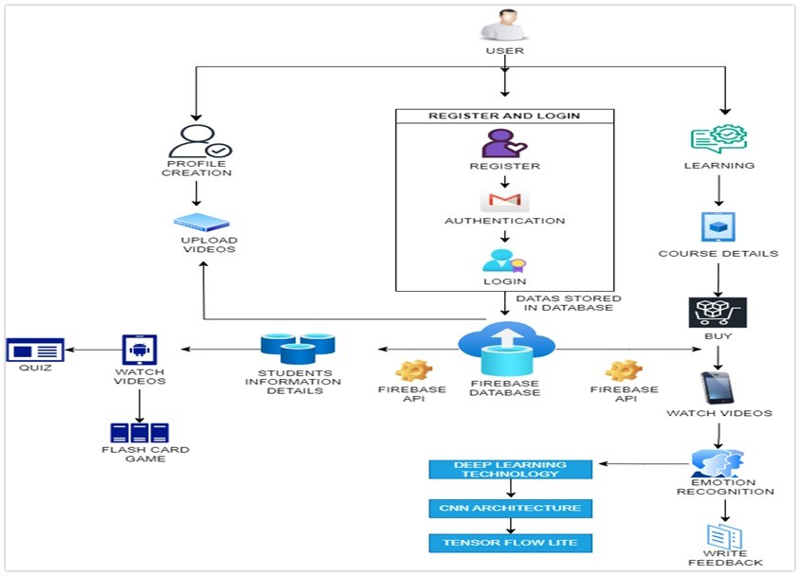

Figure 2.4 System Architecture Diagram

2.1.3.3. Data Exchange Contract:

Frequency of Data Exchanges:

Data exchanges are managed with careful consideration of timing and performance:

* Real-Time Exchanges: For critical operations like user authentication and course enrolments, data is exchanged in real-time via APIs.
* Periodic Syncs: Non-critical data, such as user activity logs or historical performance data, is synchronized at scheduled intervals.

Data Sets:

The platform handles several key data sets, each with specific exchange requirements:

* User Data: Includes personal details, credentials, and preferences. This data is exchanged during login, profile updates, and role assignments.
* Course Data: Encompasses course details, content, and metadata, exchanged during course creation, updates, and deletions.
* Enrolment Data: Tracks student progress and performance, exchanged when students enroll, complete, or drop courses.

Mode of Exchanges (API, File, Queue, etc.) :

Various methods are used for data exchange across the platform:

* API: RESTful APIs facilitate real-time data exchanges between the front-end and back-end services.
* Message Queues: Services such as RabbitMQ or AWS SQS are used for handling asynchronous tasks like sending notifications or processing background jobs.
* File-Based Exchanges: Certain data, such as bulk uploads of course materials, are handled via file exchanges, typically through S3 or similar storage services.

**2.1.4 UI DESIGN**

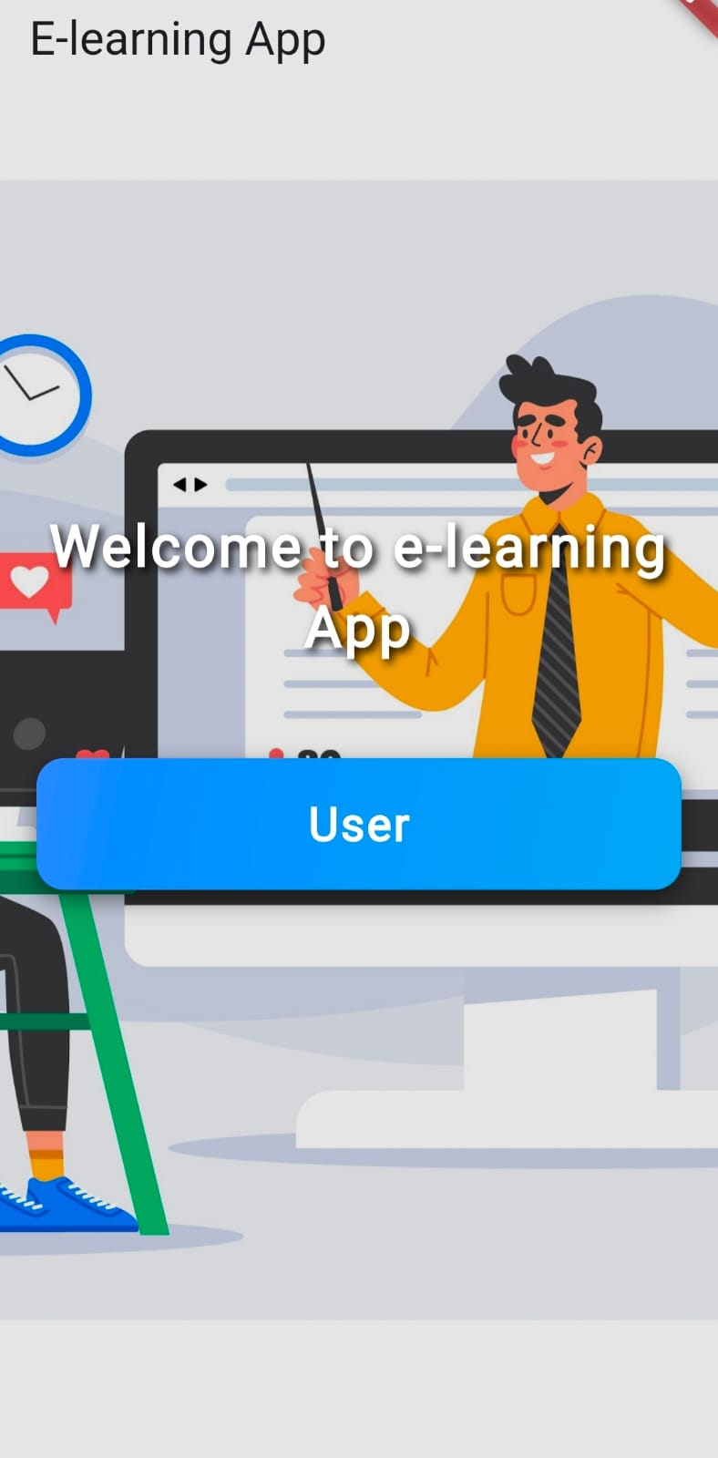

Figure 2.5 UI Design for Landing page

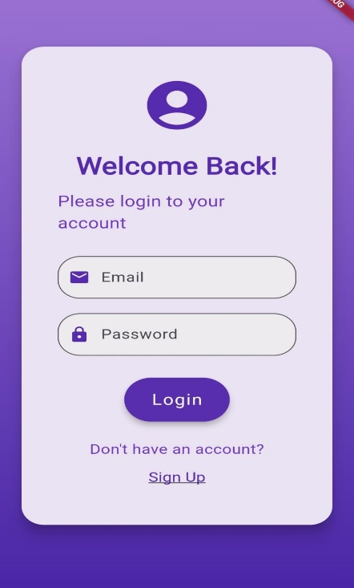

Figure 2.6 UI design for login page

**2.1.5 Functional Test Cases**

Table 2.3 Detailed Functional Test Case

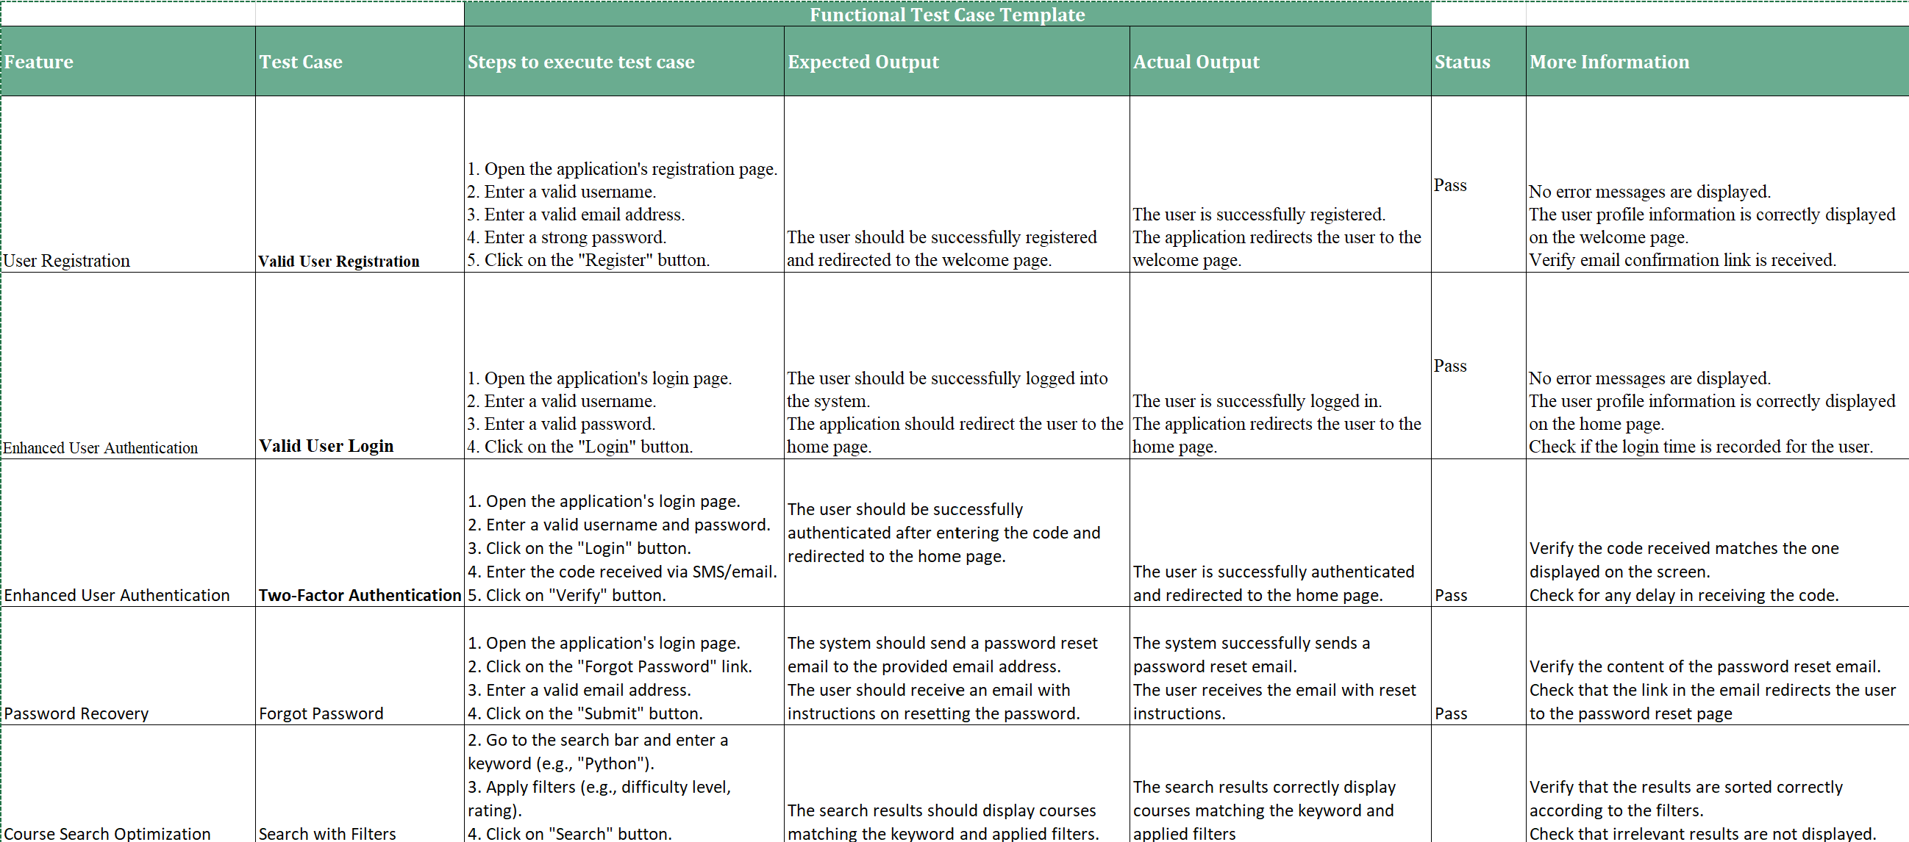

**2.1.6 Daily Call Progress**

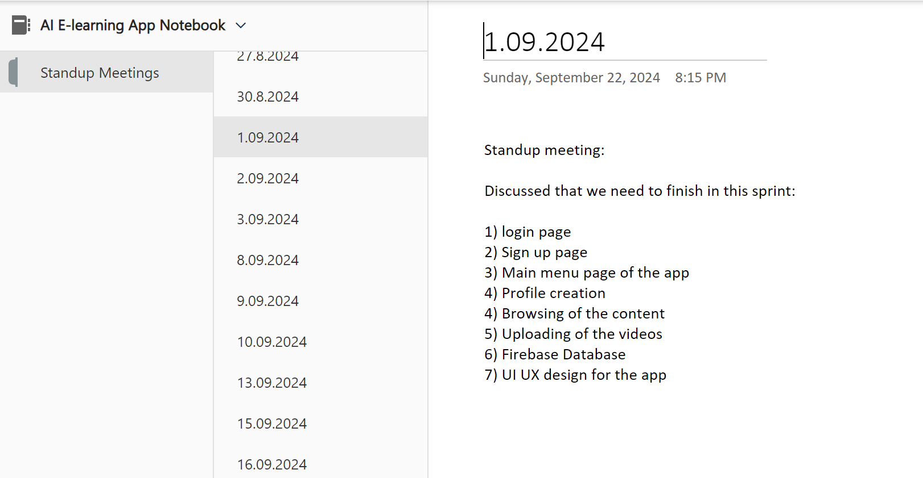

Figure 2.7 Standup meetings

**2.1.7 Committed Vs Completed User Stories**

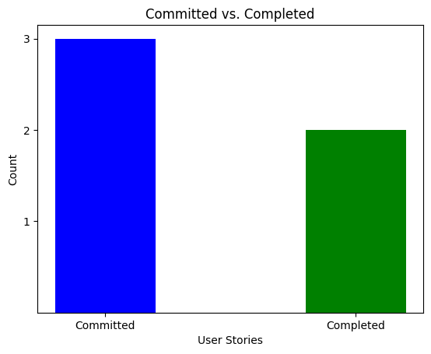

Figure 2.8 Bar graph for Committed Vs Completed User Stories

**2.1.8 Sprint Retrospective**

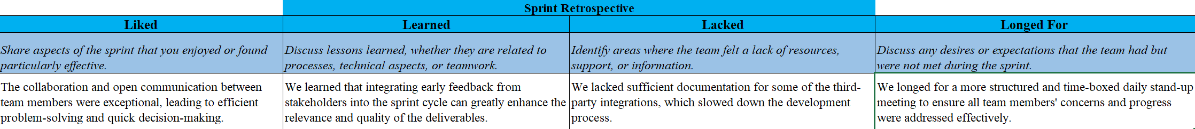

Figure 2.9 Sprint Retrospective for the Sprint 1

**2.2 SPRINT 2**

**2.2.1 Sprint Goal with User Stories of Sprint 2**

**2.2.2 Functional Document**

**2.2.3 Architecture Document**

**2.2.4 UI Design**

**2.2.5 Functional Test Cases**

**2.2.6 Daily Call Progress**

**2.2.7 COMMITTED Vs COMPLETED USER STORIES**

**2.2.8 Sprint Retrospective**

**2.3 Sprint 3**

**2.3.1 Sprint Goal with User Stories of Sprint 3**

**2.3.2 Functional Document**

**2.3.3 Architecture Document**

**2.3.4 UI Design**

**2.3.5 Functional Test Cases**

**2.3.6 Daily Call Progress**

**2.3.7 Committed Vs Completed User Stories**

**2.3.8 Sprint Retrospective**

**CHAPTER 3**

**RESULTS AND DISCUSSION**

**3.1 Project Outcomes**

**3.2 Committed Vs Completed User stories**

**(SAMPLE)**

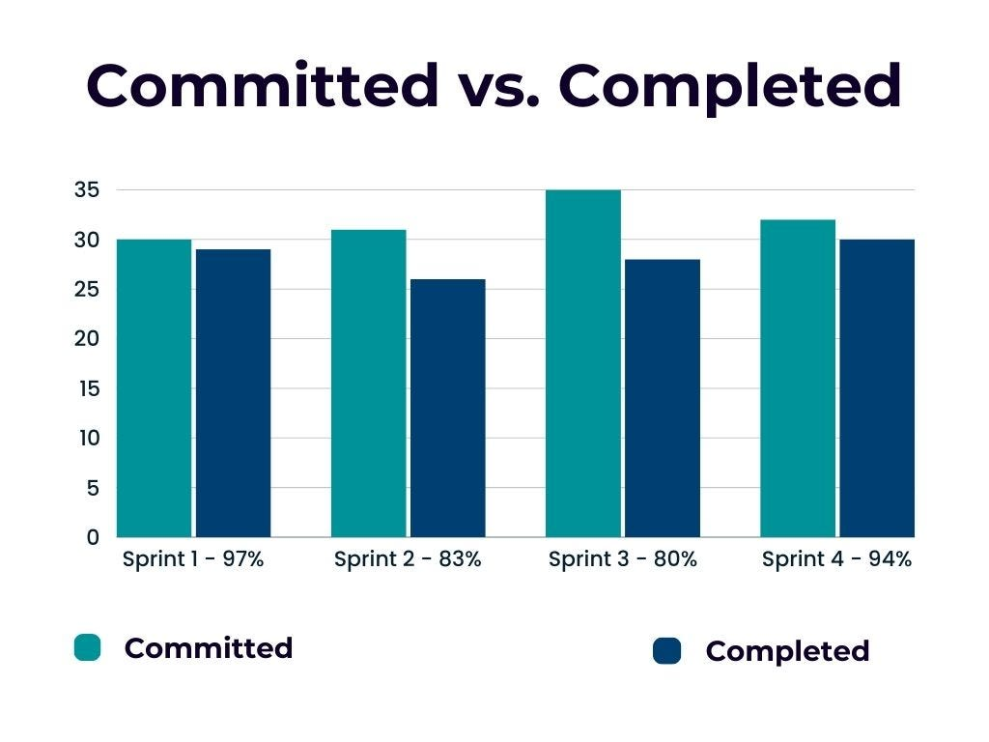

**CHAPTER 4**

**CONCLUSION & FUTURE ENHANCEMENTS**

**APPENDIX**

* 1. **PATENT DISCLOSURE FORM**
  2. **SAMPLE CODING**
  3. **PLAGIARISM REPORT**